Impact of Saline Intrusion on Social and Economic Livelihoods of Farmers in the Vietnam Mekong Delta
Van Huynh Thanh Pham ª, Rudi Febriamansyah ^{b*}, Afrizal ^{b} and Thong Anh Tran ^{c}
ª An Giang University, Long Xuyen City 88000, An Giang province, Vietnam
^{b} Universitas Andalas, Kampus Unand Limau Manis, Padang 25163, West Sumatera, Indonesia
^{c} Asian Research Institute, National University of Singapore, Singapore 119260, Singapore

Article Information |  | A B S T R A C T
Article history:  Received: September 2017  Revised: December 2017  Accepted: December 2017  Keywords:  Saline Intrusion, Vietnam Mekong Delta, shrimp farming, socio-economic impact  Correspondence:  r_febriamansyah@agr.unand.ac.id |  | One of the effects of global climate change is the increasing sea level, which has resulted in higher intrusion of sea water to the mainland in the Mekong Delta region in Vietnam. This study specifically explores the impact of saline intrusion on the socio-economic life of farmers in this region. A socioeconomic survey was carried out in two provinces in the eastern and western regions of the Delta, namely the Kien Giang province in the West and the Tra Vinh Province in the East which represented two regions, each of which experienced different levels of saline intrusion. Data collection methods include secondary data collection, focused group discussions, expert interviews, key informant interviews and 280 household questionnaire surveys. Technically, saline intrusion has changed the farming system from rice culture to shrimp culture at both sides of the Delta. Because of the need for investment in shrimp culture, a group of farming communities with large capital quickly took the opportunity to move to intensive shrimp culture. Meanwhile, other groups of farmers who lack of capital, are only able to carry out traditional rice-shrimp culture by digging around their paddy field for shrimp pond, with lower economic outcomes from their rice and shrimp production. Weak social organizations in the community, making the impact of saline intrusion is only beneficial for a few groups of people.  © 2017

Introduction
The Vietnamese Mekong Delta (VMD) is located in an important area special on socio-economic development in the southern part of Viet Nam. The Delta is a vast wetland of 40,604.7 km², accounting for 12% of the country’s total area, 27% of the agricultural land of Vietnam (MARD, 2017a). It is home to 18 million people or 20% of the country’s population (IUCN Vietnam, 2010). The Delta represents a great potential for agriculture and aquaculture production. It produces 25 million tons of rice per year (2016). Agricultural output of the Delta accounts for 50% to the whole national production. Regarding to exportation, the Delta produces about 90% of rice, 60% of fruit trees and 70% of aquaculture products (IPSARD, 2016).
The VMD lies at the downstream end of the Mekong River. It borders with Cambodia in the North, Pacific Ocean in the East, gulf of Thailand in the West and Ho Chi Minh City in the North East. The Delta is recognized by diverse hydrological characteristics varying greatly between different parts of the Delta. The upper part is characterized by flooding, lower part is dominated by close interaction with the sea (Dang, Nguyen and Nguyen, 2007). Because of its various natural conditions, water resource in the Delta is facing two problems either flood or saline intrusion (SI) Vietnam IM-HE, 2010, Le, Chu, Miller, & Bach, 2007, Käkönen, 2008, Nguyen, 2008).
Recently, SI becomes more complicated due to the impacts of climate change and human development (IPSARD, 2016, SIWRR, 2015). Saltwater has moved landwards causing risks for agriculture and livelihoods of coastal inhabitants. These saline areas are illustrated in Figure 1.
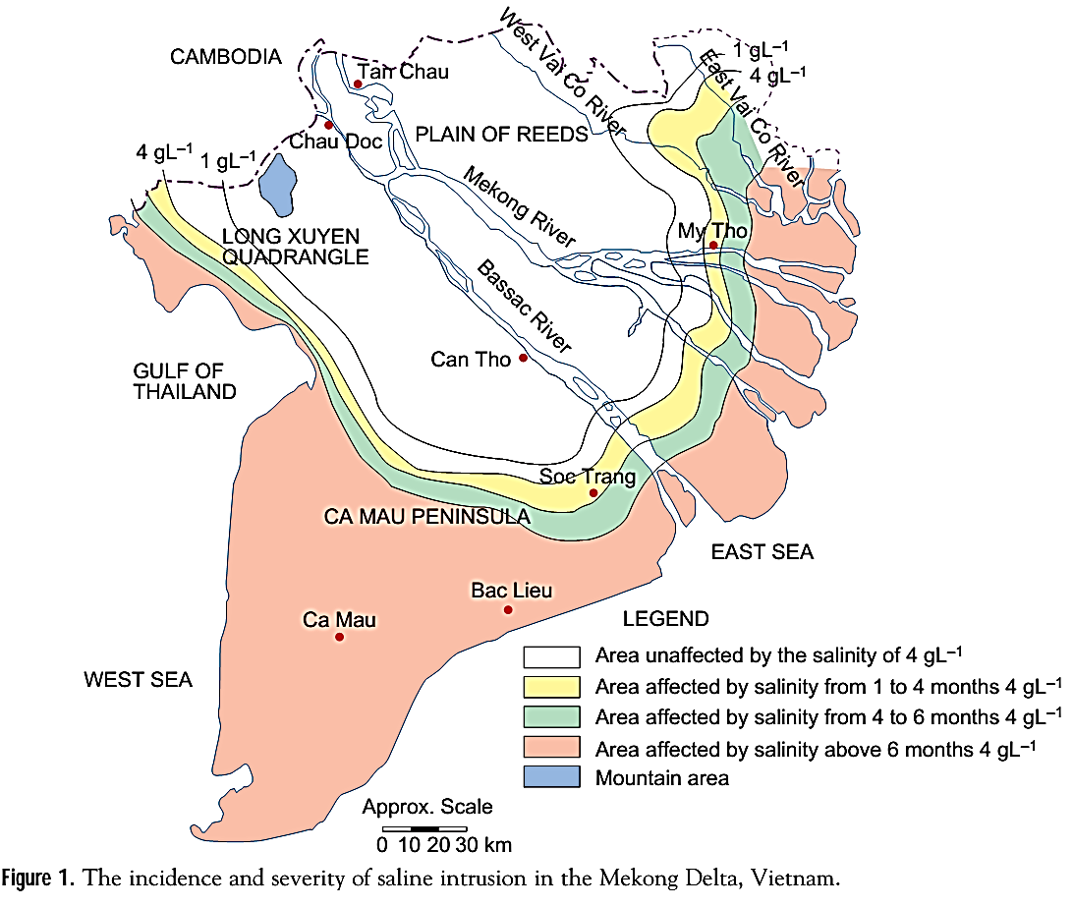
With assumption that natural conditions taking part to form impact of SI, this research are done in both sides of the delta (the west and the east sides) to get deeper understanding about economic and social impact and factors contributing into this progress in different part of the Delta. This paper will present the result of study on the social and economic impact of SI.
Figure 1. The incidence and severity of saline intrusion in the VMD
Source: (Clayton, 2003)

Research Methodology

The study sites
Previous studies have identified that SI in the eastern site are much higher than in the western site of the Delta, due to different tide effects (CCAFS-SEA, 2016; DNDPC, 2016). Therefore, this study has chosen two research sites in the VMD; Kien Giang province in the east and Tra Vinh province in the western site of Delta.
Kien Giang is a province on the western coast of this Delta (over 200 kilometers long coastline). The total population of Kien Giang is 1.738.800 (2013) people. In this province, there are one provincial city; one town; 13 districts and 145 administrative units at commune level (12 townlets, 15 wards and 118 communes). With 266 people per square km, it has a lower population density than other provinces in the VMD reflecting its rural nature and emphasis on aquaculture. 73 percent of the population lives in rural areas (ADB, 2011). While, Tra Vinh is a province on the eastern coast of the Delta, an area 2.341,2 km², population 1.012.600 (2010). There are one provincial city (Tra Vinh), one town (Duyen Hai) and seven districts including Cang Long, Tieu Can, Cau ke, Chau Thanh, Tra Cu, Cau Ngang and Duyen Hai district, and 119 administrative at the commune levels (11 wards, 12 townlets and 86 communes). The province has coastal delta topographic feature with sand dunes lying along coastal line.
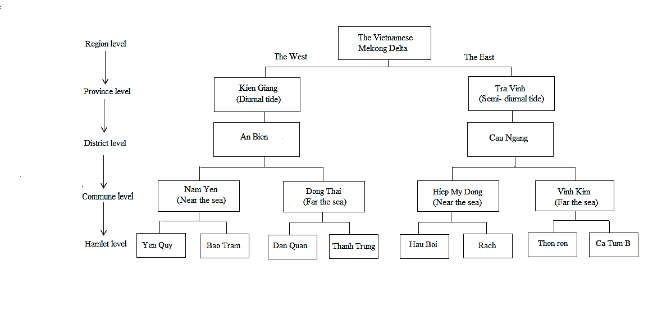
In Kien Giang province, this study has chosen An Bien district as the study site because it has been predicted by the district government to more serious salinity in the future. If the sea level rises 100cm, 95.46 percent of total land areas of An Bien district will be submerged (MONRE, 2016). There are one townlet (Thu Ba) and 8 communes (Tay Yen, Tay Yen A, Nam Yen, Hung Yen, Nam Thái, Nam Thai A, Dong Thai, Dong Yen). Data collection are collected from those two sites of the district which is divided by the 61 highways following transect from the sea to inland. Nam Yen commune in the west (near the sea) and Dong Thai commune in the east (about 20 km far from the sea).
Figure 2. Flow chart of selecting the study sites

In the east side (Tra Vinh province), research is carried out in Cau Ngang district. The district locates on the southeast of Tra Vinh province, an area 32.836,39 ha (accounting for 14.31% natural total land of province). Cau Ngang is relatively flat with the topography from 0.40 m – 0.60 m. The district has been affected by drought and saline intrusion influencing on the land use within the district. Every year, salt concentration in water increases from Febuary to April (Cau Ngang People's Committee, 2015. Like research sites in the west, two communes Hiep My Dong commune (near the sea) and Vinh Kim commune (about 30 km far from sea) are chosen to be research sites.
In fact, the selection of study sites is summarized in Figure 2. The process of randomization follows proportional stratified sampling.
Two provinces representative for the two main ecological regions in the Mekong Delta having different tide schemes, semi- diurnal tide in the east and diurnal tide in the west are selected. At the province level, one representative district is selected. In each district, there are two communes are studied including one near and one far the sea. For each commune, two hamlets are selected randomly because of small commune area. Totally, 8 hamlets were studied.

Methods for data collection
The study used a mixed method approach that integrated both qualitative and quantitative data collection approaches as follows:
Collection of secondary data: data gathered in this step are saline intrusion status, social – economic and political situation. Policy documents at the Mekong Delta related to strategy of the Delta’s development, climate change adaptation and especially in case of saline intrusion, market situation are also collected. Group discussion: Four group meetings were held in the four communes, aimed at understanding the SI tendency, its impacts and local adaptation processes. Participants are those farmers who are living more than 10 years in these areas. Around 7-10 people attended the meetings. Tools used for interviews are mapping timeline, problem tree.
Key informant interview: For people working at governmental organization at the three levels (province, district and commune) are interviewed to get the general understanding about the current situations of SI, adaptation patterns and also the policies applied to support local inhabitants.
For expert interview: Interviewees have good knowledge in terms of SI. They have been working in this field for longer time or living in those areas which have been affected by SI. Experts from Can Tho Climate change and Delta Development Institution, Ho Chi Minh science University, the two universities famous for doing research in this field are questioned. Experts from Kien Giang and Tra Vinh University also are interviewed for better understand of local situation, economic and social impacts.
Household survey Questionnaire: A set of structured questionnaires which are designed according to the results of the qualitative approach are administered to the household in Kien Giang and Tra Vinh province. Totally, 280 households from 8 hamlets are chosen as the respondents for this study. To avoid those who are newcomer and do not farm directly, a purposive sampling method is used to choose the households following two criteria: Living in these areas for more than 10 years and having and farming directly on the farms.

Results and Discussion

Saline intrusion’s impacts
In general, impacts of SI on agricultural products have been reported recently in the VMD, especially in April of 2016. Because rice is main crop in the Delta, data of crop lost by SI is reported clearly in case of rice than other crops. They are calculated both in areas and financial loss. In the year 2016, 208,000 ha of rice (loss more than 70% of yield), 9,400 ha of fruit trees; 2,000 ha of aquaculture were lost reported by (MARD), 2016). Nine provinces (9/13 provinces in the Delta) had announced to be in emergency case. Number of rice area damaged is displayed in Table 1.
Table 1. Areas and loss of rice due to saltwater in the VMD
Province | Area (ha) | Loss (million VND)
Long An | 8,651 | 10,812
Tien Giang | 1,021 | 2,038
Ben Tre | 13,844 | 25,700
Tra Vinh | 11,014 | 4,913
Kien Giang | 34,093 | 61,335
Soc Trang | 9,505 | 14,075
Bac Lieu | 11,456 | 18,270
Ca Mau | 49,343 | 78,049
Hau Giang | 1,203
Total | 140,130 | 215,192
Source: Central steering committee for natural disaster prevention and control (2016), (Up to March 2016)

For the whole Delta, the total damage across all fields is calculated up to 360 million USD. Regarding to agricultural and aquaculture fields, loss is more than 300 million USD (Nguyen, 2017).
In specific, this study has identified that most farmers having problem with the availability of fresh water for their rice culture, 35.81% of farmers in An Bien; 20.09% of farmers in Cau Ngang mentioned that they are having lack of fresh water for rice farming (see Table 2.). Uncertainty of fresh water during the period of rice culture also brings difficulties, due to the high fluctuation of SI into their land. Too salt is not good for rice cultivation, while too fresh and too salty not good for shrimp. SI can be seen as natural risk depending on the salt concentration.
Table 2. Impact of saline intrusion on agriculture and livelihood (n=280)
Impacts of SI | An Bien district  (The West) |  | Cau Ngang district  (The East)
 | Freq. | % | Freq. | %
Lack of fresh water for rice (rice dead) | 106 | 35.81 | 42 | 26.09
Uncertain water source (too salt/fresh) | 67 | 22.64 | 37 | 22.98
Lack of fresh water for daily activity | 81 | 27.36 | 28 | 17.39
More money for family expenditure | 37 | 12.50 | 29 | 18.01
Others (more illness) | 5 | 1.69 | 25 | 15.53
Total | 296 | 100.00 | 161 | 100.00

Farmers in An Bien district stated that there are many symbols to recognized that the field has been affected by salt water. Damages of rice depend on growing stage. Symbol can be leaves turn white and dry, plant stunting and reduced tillering and as the result it causes low yield or no harvest. A research conducted by Cuu Long Rice Institute in O Mon district in Can Tho City (O Mon Rice Institute) explored a numbers of rice varieties which can manage within salt level about 4g/L. It raises an opportunity for farmers having better choice. In fact, due to agriculture is the main source of income in these areas, SI affects agricultural and human life causes household vulnerability. Farming system changing is response to saline intrusion effect.

The changes of farming system

Time of shifting farming system
Due to SI, farmers have made use of resource available - brackish or salt water source. SI brings good chance to raise shrimp. Driven by increasing SI impacts on livelihood in both sides of the Delta, farmers shifted rice to shrimp farming practices. The land use change was linked closely to the level of salinity encroaching into both sides of the Delta, this explains the frequent shifts of farming systems undertaken by farmers in response to change. The shift from agriculture to shrimp farming in the East was applied earlier than in the West of the VMD. The integrated shrimp-rice farming in Cau Ngang district applied in the year of 1990s while in An Bien district started in the year of 2000s.
Since then, the shrimp cultivation takes two main forms: (1) extensive (low density) shrimp rice cultivation is a rotation system, shrimp culture which is dependent on salt water available in the dry season, followed by a rice crop in the rainy season, when fresh water is available (without or little feed supply); density of shrimp is about 1-2 shrimp fries/m², and (2) intensive (high density) shrimp cultivation includes two or more shrimp crops per year, (with feed supply); density of 30-50 shrimp fries/m2. Highly intensive shrimp system indicates higher density of shrimp fries in the pond, around 100-150 fries/m².
In the west, rain-fed rice farming area where rain is main source of water for growing rice. Farmers have less adaptive choices. They cannot change into other crops like fruit trees or upland crops due to lack of fresh water (Pham and Febriamansyah., 2017). Farmers develop shrimp rice system. They do shrimp culture in the dry season and rice culture in the wet season. Shrimp crop starts at December or January depending on yearly seasonal calendar allowed by Agriculture and Rural Development Department at district level.
In shrimp rice system, Tôm Sú - Giant tiger prawn shrimp (Penaeus monodon) are raised because they require less or no food added. In some years, if the salt level in water is not high enough, farmers replace Giant tiger prawn shrimp by Tôm càng xanh - Giant freshwater prawn shrimp (Macrobrachium rosenbergii) or fish to maintain income sources. Giant freshwater prawn shrimp manages well in lower level of salt in water from 4-6g/L while optimum level of salt concentration for Giant tiger prawn shrimp is 8-20g/L. Base on their own knowledge, farmers are flexible to response to uncertain climate risk.
In contrary, in Cau Ngang district (the eastern of Delta), farming systems are more diversified including both intensive and extensive shrimp system. While shrimp rice system is applied widely in the West, it is more intensive shrimp in the East. Under impacts of SI, a commune officer in Hiep My Dong commune, Cau Ngang District, Tra Vinh, expressed that intensive shrimp system has been well developed since 2008. Due to its low price of rice in the market, rice was only planted for family consumption. It was not a farmer’s attention due to its low profits. Compared with rice, shrimp brings relatively better income. Farmers switched to this farming practice when they saw their fellow farmers’ success in neighboring areas.
There is also an interesting issue related to making decision of choosing types of shrimp system of old and young farmers in Cau Ngang district. Old farmers (above 50 years old) want to keep shrimp rice system because rice is basis food needed for family food security. When they have enough rice for all family members for a period of time (usually calculating by 6 months or one year) they feel save. Young farmers do differently. They want to apply intensive shrimp rice system because it brings a lot of benefit. If they have money they can buy whatever they want. They accept to take the risk. A farmer said that “Trồng lúa không có lời, nên phải chuyển thôi. Lúa trồng chủ yếu để ăn. Thấy hàng xóm làm được nên làm theo. Rice gives no profit, I have to change. Growing rice is only for the families’ consumption. I shifted from rice to shrimp farming when I saw my neighbours did well”

Economic impacts

More sources of income from shrimp rice system in the west
Changing farming systems is response to adapt to SI. Farmers in the West have shifted from double rice to shrimp rice system since it brings better income. Table 3 shows that the profits from shrimp are much more than rice (6.63 and 1.35). More important sources of income have been increased from one source from rice to two sources from rice and shrimp. Local farmers do not consider income source from rice is important (as it is smaller than shrimp), existing of rice is basic need for next shrimp crop to be sustainable. A farmer in Nam Yen commune, An Bien district said that “Trồng lúa chỉ để làm thức ăn cho vụ tôm tiếp theo, vì nếu không có gốc rạ trên ruộng thì tôm sẽ không có thức ăn – rice is grown because of the next shrimp crop, without rice straw left on the paddy, no food source for shrimp.

Table 3. Cost and profit of shrimp rice system in An Bien, unit: 1000VND(*)/ha; (n=140)
Cost and Benefit | Shrimp | Rice
Cost (not including family labour) (C) | 10,641 | 12,659
Cost (including family labour) (CF) | 16,584 | 14,381
Gross income (GI) | 81,144 | 29,027
Profit without family labour (P) | 70,503 | 16,694
Profit including family labour (PF) | 65,059 | 14,645
P/C | 6.63 | 1.35
PF/CF | 3.92 | 1.01
(*) VND: Viet Nam Dong - currency in Vietnam
Most farmers in An Bien district consider shrimp rice system is sustainable as it is more profit and requires less labour. For shrimp rice farmers, they can earn money twice a month from shrimp when tide is high (15th and 30th Lunar calendar). It is better than waiting for three months to get money from rice crop. Importantly, they can deal with the situation of unstable market prices. If one fails, another can support their families to live (Pham and Febriamansyah, 2017). A farmer in An Bien district informed that “ Tôm lúa trồng khỏe lắm, ít tốn nhân công mà có lời nhiều. Nhà có hai mẹ con mà cũng chăm sóc được - Shrimp rice system is good as it is less labour-intensive and brings more profits. Like my family with two people, myself and a son, this model therefore is very suitable.

Economic gain from intensive shrimp but high risk in the East
On the other hand, it was clear that farmers in the East side preferred adopting the intensive system because it brings better income than shrimp-rice. It is clear to see that intensive shrimp gives farmers big profits in good case. Intensive shrimp gives farmers a chance to have more profit (Table 4). A male farmer in Hiep My Dong commune expressed that “Lúa bây giờ trồng năng suất thấp (3 tấn/ha so với 6 tấn/ha ở 10 năm trước. Tôi chuyển qua nuôi tôm mặc dù biết rằng nhiều rủi ro- Rice yield is currently too low (3 tons/ha compared with 6 tons in 10 years ago), I keenly switched to shrimp although I realise its high risks”. Shrimp farming needs huge investment but once being successful, it could bring better returns. The ratio of P/C and PF/CF is not high (1.42 and 1.02 for 1st crop and 0.97 and 0.90 for 2nd), but it is huge investment, farmers have chances to get more money.

Table 4. Cost and profits of intensive shrimp farming system in Cau Ngang district, unit:1000VND/ha; (n=105)
Cost and Profits | 1st Shrimp | 2ndShrimp
Cost (not including family labour) (C) | 314,326 | 309,201
Cost (including family labour) (CF) | 324,316 | 323,412
Gross income (GI) | 654,921 | 610,664
Profit without family labour (P) | 444,837 | 298,882
Profit including family labour (PF) | 330,806 | 289,701
P/C | 1.42 | 0.97
PF/CF | 1.02 | 0.90

Regarding to risk of intensive shrimp system, it is high. Data reported from Department of Agriculture and Rural Development in Cau Ngang district shows that about 30% (in average) of shrimp farmers in the district for four years from 20014- 2017 did not get profit for both Giant tiger prawn and Tôm thẻ chân trắng (White-leg shrimp) (Table 5).

Social changes

Constraints to adapt the SI
The result shows that there are challenges existing, difficulties for both the West and the East is lacking technique and high investment (Table 6). These two factors have dominantly influenced the decision of farmers to shift their farm land from rice to shrimp. Those who have capacity (mostly young farmers) and capital (rich farmers) mostly in the east have tried to adapt with the SI.

Table 5. Rate of households having profits and losing investment
Rate (%) |  | Years |  |  |  | Ave.
 |  | 2014 | 2015 | 2016 | 2017
Giant tiger prawn
 | Having profit | 79.2 | 39.6 | 59.7 | 63.1 | 60.4
 | Breaking even | 6.8 | 8.7 | 7.0 | 3.6 | 6.5
 | Losing money | 14.0 | 51.7 | 33.3 | 33.3 | 33.1
White-leg shrimp
 | Having profit | 69.7 | 48.9 | 63.2 | 71.6 | 63.3
 | Breaking even | 3.6 | 11.0 | 7.4 | 8.8 | 7.7
 | Losing money | 26.7 | 40.3 | 29.4 | 19.6 | 29.0
Source: Department of Agriculture and Rural Development in Cau Ngang district, 2010 - 2016
Table 6. Difficulties of shifting from rice to shrimp culture (n=280)
Difficulties | An Bien district  The West |  | Cau Ngang district  The East
 | Freq. | % | Freq. | %
Technical constraints | 105 | 44.12 | 93 | 40.26
Capital investment constraint | 75 | 31.51 | 96 | 41.56
Unsuitable SI status | 40 | 16.81 | 31 | 13.42
Conflict due to water demand | 6 | 2.52 | 2 | 0.87
Others (high disease) | 12 | 5.04 | 9 | 3.90
Total | 238 | 100 | 231 | 100

Originally, all respondents of this study rice farmers. When they face the reality that their farmlands are not suitable for rice for year around due to the salinity of their water sources, they have to think to see the possibility to shift their rice land for shrimp farm. However, they have to consider the technical and capital constraints to shift their farm business. In fact, mostly young farmers and those who have enough capital will change their farm because of this condition and also challenge this opportunity to get more benefit from shrimp farming compare to rice farming.
Lack of money for investment is mentioned by farmers in two areas, the west (40.12%) and the east (40.26%). Farmers need more than 300 million VND for every season to invest for intensive shrimp system. Changing farming system is a potential threat to the poor rice farmers as aquaculture is not an accessible opportunity to the poorest due to the required levels of capital.
Not all farmers are able to move from rice to shrimp crop because they have no money for investment or farm size is not big enough for changing into shrimp farms (mainly for the west). A lot of money is needed in first year for preparing farm, ditching pond and also learning techniques. This issue is mentioned by some researches. Tran and Le, (2011) indicated that intensive shrimp is not for all because changing farming system from rice to shrimp would poses a potential difficulty to the poor rice farmers due to high levels of capitals. The farmers have more land have better adaptive capability than the poor and farms having less land (Vo et al., 2014). Group of rice farmers who are poorer (less land, no money…) are more vulnerable. They are vulnerable not only from climate risk but also from their neighbor decisions.
Table 7. Impacts of SI on social dimensions
Dimensions | An Bien district  The West | Cau Ngang district  The East
Self-management to established organization | More in the west | Less in the east
 | - Groups of shrimp rice farmers go together to organize to share water resource and techniques due to water scarcity and lacking techniques sharing.  - Labour manages works to share among members of the community. | - Groups are built based on governmental support
Social structure – emerging of group leaders’ role | More in the west | Less in the east
 | - Emerging roles of group leader to build and maintain group.  - Roles of leaders in to get connection with local officers (lobby activities). | - Roles of group leader important in case having the Government supports (lobby activities)
Social connection - among farmers and between farmers and other local agencies | More in the west | Less in the east
 | - Connections among farmers are more due to sharing natural resources and also benefits are related to others.  - Close connection with local technique officers | - Connection among farmers if less due to high investment, farmers seem to work independently in technique field;  - Supporting from the Government is brought to all members of group.

Social change to solve difficulties
Impacts of climate change influence social change related to changes of social structure (referred to the way society organized), institution and social context (Appelbaum, 1970, Pelling and High, 2005). Due to different status of SI, there are various changes from the west and east which are displayed in Table 7. It shows that farmers in the west are more self-management to manage water resources, sharing technique. For people who are labour, they have work together for building group to work and share jobs among labour in the community. In the west where farmers have showed more indicators that they have tried to work together to manage themselves to solves the problems.
The table shows that more indication of social changes happened in the west than in the east. In the four communes of research sites, social changes have been found in the two communes locating near the sea (Nam Yen in the West and Hiep My Dong commune in the East) because SI happened serious which make farmers have to make change to adapt. However, scales of changes are different from West to East. Farmers in the west show their ability to change more than farmers in the East. The reasons for those differences are related to demographic factors, natural conditions, technology and cultural factors. Those factors contribute to make social change process variously in both sides. Those factors come from both environmental and social sides since they are related to other.

Conclusion
Changing farming systems, a main response to adapt to SI has been taken by both farmers in the west and the east. Farmers in the west have shifted from double rice to shrimp rice system since it brings better income. The profits from shrimp are much more than rice, however existing of rice is the basic need for shrimp crop to be sustainable. Importantly, more sources of income have been increased from one source of rice to two sources of rice and shrimp helping farmer to get regular income. On the other hand, it was clear that farmers in the East side preferred adopting the intensive system because it brings better income than shrimp rice system. However, risk is high, big profits only exist in good case. In shifting process, lack of technique and financial investment challenges farmers in both areas. Social changes happen variously in both cases to overcome the difficulties. It is more in the west helping local farmers to manage water resources and for technical sharing while it is less in the east where farmers reply more on the governmental support. The reasons for those differences are related to demographic factors, natural conditions, technology and cultural factors. In fact, social changes indicating adaptive capacity of the communities contribute to reduce vulnerabilities of climate risk.

References
ADB (Asian Development Bank). (2011). Consultant report on Climate Change Impact and Adaptation Study in the Mekong Delta- (Part A) Kien Giang Atlas Melbourne, Australia: Vietnam Institute of Meteorology, Hydrology and Environment and the Kien Giang People Committee.
Appelbaum, R. P. (1970). Theories of social change: Markham Publishing Company Chicago.
Cau Ngang People's Committee. (2015). Land use plan to 2020 in Cau Ngang district. Cau Ngang district, Tra Vinh province: Based on document 528/QĐ- UBND date 21/4/2014. Tra Vinh People's Committee.
CCAFS-SA (Climate Change, Agriculture and Food Security- Southeast Asia). (2016). The drought and salinity intrusion in the Mekong River Delta of Vietnam: Assessment Report. Ha Noi. Research Program on Climate Change, Agriculture and Food Security- Southeast Asia.
Clayton, H. (2003). Rice–shrimp farming in the Mekong Delta: biophysical and socioeconomic issues.
Dang, N. K., Nguyen, B. V., & Nguyen, T. H. (2007). Water use and competition in the Mekong Delta, Vietnam Challenges to sustainable development in the Mekong Delta: regional and national policy issues and research needs. (pp. 143-188): The Sustainable Mekong Research Network.
Department of Agriculture and Rural Development in Cau Ngang district (2010 – 2016). Report for end of year and strategy for next year in Cau Ngang district, Tra Vinh province.
DNDPC (Department of Natural Disaster Prevention and Control). (2016). Status of drought and saline intrusion in the Vietnamese Mekong Delta in 2016. Ha Noi.
IPSARD (Instituition of Policy and Strategy for Agriculture and Rural Development). (2016). Drought and saline intrusion in the Mekong Delta - Adaptations from rice farmers, local goverment and solutions – Hạn và xâm nhập mặn tại ĐBSCL- thích ứng từ nông dân, nhà quản lý và giải pháp. Ha Noi.
IUCN Vietnam (International Union for The Conservation of Nature in Vietnam). (2010). Experts group report - Mekong Deta situation analysis.
Käkönen, M. (2008). Mekong Delta at the crossroads: more control or adaptation? Ambio: a journal of the human environment, 37(3), 205-212.
MARD (Ministry of Agriculture and Rural Development). (2016). Regional environmental assessment report on Mekong Delta integrated climate resilience and sustainable livelihoods project (MD-ICRSL). Ha Noi Ministry of Agriculture and Rural Development.
MARDa (Ministry of Agriculture and Rural Development). (2017). Strategies for water management in the Mekong Delta to adapt to climate change situation - Định hướng phát triển thủy lợi vùng Đồng Bằng Sông Cửu Long. Paper presented at the Conference of sustainable and climate resilience development of the Mekong Delta of Vietnam, Can Tho.
MARDb (Ministry of Agriculture and Rural Development ). (2017). Strategies for changing crop struture to achieve sustainable agriculture in sub- regions in the Vietnamese Mekong Delta. Giải pháp chuyển đổi nông nghiệp bền vững cho các tiểu vùng tại Đồng Bằng Sông Cửu Long. Paper presented at the Conference of sustainable and climate resilience development of the Mekong Delta of Vietnam Can Tho.
MONRE (Ministry of Environment and Natural Resource). (2016). Scenarios for climate change and sea level rise in Vietnam. Environmental resources and map of Vietnam, Ha Noi.
Nguyen, A. D. (2008). Salt intrusion, tides and mixing in multi-channel estuaries. PhD Thesis, UNESCO-IHE Institute for Water Education, Delft, The Netherlands.
Nguyen, A. N. (2017). Historic drought and salinity intrusion in the Mekong Delta in 2016: Lessons learned and response solutions- Lịch sử về hạn và xâm nhập mặn tại D9BSCL năm 2016: Bài học kinh nghiệm và giải pháp. Vietnam Science and Technology, 1(1), 93-96.
Pelling, M. & High, C. 2005. Understanding adaptation: What can social capital offer assessments of adaptive capacity? Global environmental change, 15, 308-319.
Pham, V. H. T., & Febriamansyah, R. (2017). Explore forms and factors affecting collective adaptation to salt water intrusion in the Mekong delta of Vietnam. Paper presented at the The XVI Biennial IASC Conference - Practicing the commons: self-governance, cooperation, and institutional change, Utrecht University, The Netherlands. http://dlc.dlib.indiana.edu/dlc/handle/10535/10412
SIWRR (Southern Institute of Water Resources Research). (2015). Saline intrusion status in the Mekong Delta report – Báo cáo về tình hình xâm nhập mặn tại ĐBSCL. Ho Chi Minh Southern Institute of Water Resources Research.
Tran, T. A., & Le, P. T. (2011). Impacts of saline intrusion on poor households’livelihoods in coastal areas of Ben Tre province. RDV project. Hue University.
Vietnam CSNDPC (Central Steering Committee for Natural Disaster Prevention and Control in Vietnam). (2016). Damages from drought and saline intrusion in the Mekong delta of Vietnam.
Vietnam IM-HE (Institute of Meteorology - Hydrology and Environment). (2010). Climate change effects on water resource and adaptation in the Mekong delta of Vietnam . Ha Noi Vietnam Institute of Meteorology, Hydrology and Environment.
Vo, V. T., Le, C. D., Vo, V. H., & Dang, K. N. (2014). The farmers' capacity to adapt with climate change in the Mekong Delta. Can Tho University Scientific Journal, Part D (31)(Political Science, economic and law ), 63-72.

Hamlet is not an administrative level, person working as head or vice head of hamlet is not governmental officers but they get allowance from the Government monthly. This level has close connection with community members.
Farmers harvest shrimp by net. At time of high tide shrimps have habit to move. Based on natural water flow, farmers collect shrimp. This way of harvest does not affect the rest still living in the pond (Phan. V. U. Farmers in An Bien district, In- depth interview , 2018).
The result find that investment for shrimp rice at the first time is about 50- 80 million VND per ha; from rice to intensive shrimp is bout 150 – 200 million VND per ha.

